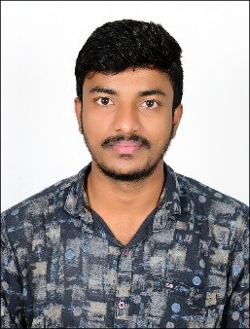

**RESUME**

**SANTOSHAKUMARA S**

Mobile Number: 8884739055

Em[ail id: santoshspk1234@gmail.com](mailto:jayanthchandrika@gmail.com)

# CARREIR OBJECTIVE:

To work in a challenging and dynamic environment where I will be able to contribute the best of my skills and efforts for the growth of the organization and as well to obtain a position to grow and learn more as a professional in my field.



**ACADEMIC CHRONICLE:**

|  |  |  |  |  |
| --- | --- | --- | --- | --- |
| **Course** | **Institution** | **Board/ University** | **Year of passing** | **CGPA/**  **Percentage** |
| BE in ECE | PES Bangalore South Campus | Visvesvaraya Technical University (VTU) | 2021 | 6.07 |
| PUC | SMJ science PU college Sindhanur | Department of Pre- University Education Bengaluru | 2016 | 80.83% |
| SSLC | Government High School, Saalagundha | Karnataka Secondary  Education Examination Board (KSEEB) | 2014 | 81.12% |

# PERSONAL SKILLS:

* Strong commitment for target achievement.
* Quick Learner.
* Self Confidence.
* Time management and prioritizing and planning to work efficiently.
* Ready to take challenges and having good problem solving skills.

# LANGUAGES KNOWN:

* English, Kannada, Hindi, Telugu.

# HOBBIES:

* Solving Aptitude and Reasoning questions
* Playing Sports and Games
* Reading newspaper and Solving Daily Sudoku

# PROJECT WORK:

* Modelling and Simulation of semiconductor quantum dots
* Geo-fencing Robot

 **TECHNICAL SKILLS:**

* + Java basics
  + Core java
  + Knowledge on C programming
  + SQL Oracle
  + Circuit Analysis



**PERSONAL PROFILE:**

Name : Santoshakumara S

Father Name : Pampapati S

Date of Birth : 09-06-1998

Gender : Male

Nationality : Indian

Religion : Hindu

Marital Status : Single

Permanent Address : Behind Satkar hotel, Near bhavikatte,

Katibase colony, ward no.6, Sindhanur -584128

# DECLARATION:

In view of the above I request you to kindly consider my application and give me an opportunity to serve in your esteemed organization. I hear by declare that the above written particulars are true to the best of my knowledge and belief.

Date :

Place:

Yours faithfully,

# Santosh kumar S